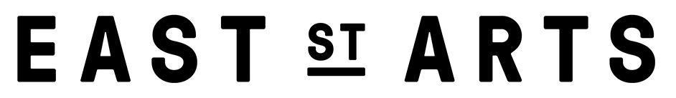

APPLICATION FORM

SECTION ONE

CONFIDENTIAL APPLICATION FOR EMPLOYMENT
This application form and the personal details it contains will be kept on record.

POSITION APPLIED FOR:

SURNAME:

FORENAMES:

ADDRESS:

DAYTIME TELEPHONE NO:

EVENING TELEPHONE NO:

EMAIL ADDRESS:

DATE OF BIRTH:

NI NUMBER:

PLACE OF BIRTH:

NATIONALITY:

SECTION TWO

PREVIOUS EMPLOYMENT
Please detail your work history (paid or unpaid) with your current or most recent employer first:

Name and Address of Employer From To

Rate of Pay
Reason for Leaving

Position Held and Duties Undertaken

If offered employment how much notice are you required to give your current employer?
WORK HISTORY (continued)
Please list your work history below and on a separate sheet if necessary:

EDUCATION and TRAINING
Please give details and dates of completion of relevant qualifications and training:

FURTHER SUPPORTING INFORMATION
Please outline what personal attributes and characteristics you feel qualify you for this post along with any other information. You might want to let us know:
- Why you are interested in this role and contributing to the work of East Street Arts.
- What skills, knowledge and experiences you have that are relevant to the role.
- Your top three professional achievements and why you’re proud of them.
- Self-describe any barriers you may have faced in gaining access to the arts. You may also want to identify how you overcame those barriers and / or what further resources might help with this if these barriers remain in place.
(no more than 800 words)

REFERENCES

Please give below the names and addresses of two referees.

1)

2)

DECLARATION

I authorise East Street Arts to obtain references to support this application once an offer has been made and accepted and release the company and referees from any liability caused by giving and receiving information. I accept that any offer made is subject to the receipt of references and Disclosure and Barring Service (DBS) checks that are satisfactory to the Company.

I confirm that the information given on this form is, to the best of my knowledge, true and complete. Any false statement may be sufficient cause for rejection or, if employed, dismissal. I also accept that it is my personal responsibility to notify the Company of any employment I accept other than the position for which I am employed and to declare on a weekly basis the actual hours worked.

Signature:

Date:

